# Project Design Phase-II

**Data Flow Diagram & User Stories**

|  |  |
| --- | --- |
| **Date** | 26 October 2022 |
| **Team ID** | PNT2022TMID45909 |
| **Project Name** | Plasma Donor Application |
| **Maximum Marks** | 4 Marks |

## Data Flow Diagrams:

Data Flow Diagram (DFD) is a traditional visual representation of the information flows within a system. A neat and clear DFD can depict the right amount of the system requirement graphically. It shows how data enters and leaves the system, what changes the information, and where data is stored.

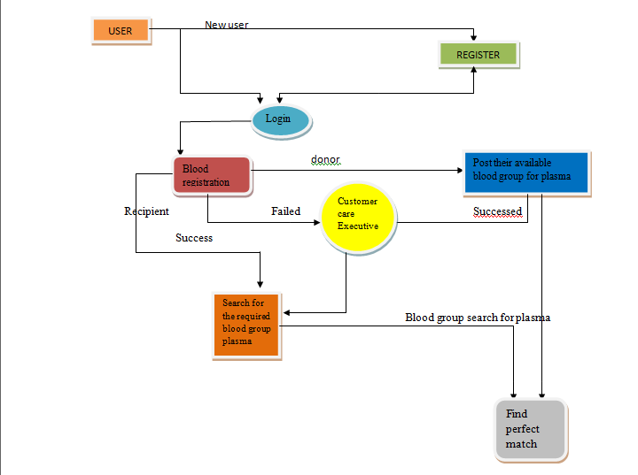

## User Stories

Use the below template to list all the user stories for the product.

|  |  |  |  |  |  |  |
| --- | --- | --- | --- | --- | --- | --- |
| **User Type** | **Functional**  **Requirement (Epic)** | **User Story Number** | **User Story / Task** | **Acceptance criteria** | **Priority** | **Release** |
| Customer (Mobile user) | Registration | USN-1 | As a user, I can register for the application by entering my email, password, and confirming  my password. | I can access my account / dashboard | High | Sprint-1 |
|  |  | USN-2 | As a user, I will receive confirmation email once I have registered for the application | I can receive confirmation email & click confirm | High | Sprint-1 |
|  |  | USN-3 | As a user, I can register for the application through Facebook | I can register & access the dashboard with Facebook Login | Low | Sprint-2 |
|  |  | USN-4 | As a user, I can register for the application through Gmail | I can register the app with Gmail login. | Medium | Sprint-1 |
|  | Login | USN-5 | As a user, I can log into the application by entering email & password | I can register & access the dashboard with Gmail  Login | High | Sprint-1 |
|  | Dashboard | USN-6 | As a user, I can search the blood group for which I need plasma. | I can get perfectly-  matched plasma through filters. | High | Sprint-2 |
| Customer (Web user) | Dashboard | USN-7 | As a user, I can see login page and registration page for which the user logins and searches for the required blood group plasma. | I can login through Gmail and Facebook and register  for my required blood group plasma. | Medium | Sprint-2 |
| Customer Care Executive | Dashboard | USN-8 | As a customer care executive, I can solve the queries of the users. | I can reply to their queries and solve their related problems. | High | Sprint-3 |
| Administrator | Registration | USN-9 | As an Administrator, I can view the database of the registered users. | I can see who are the  persons registered here and their mail ids. | Medium | Sprint-4 |
|  | Dashboard | USN-10 | As an Administrator, I can view how many  members need what kind of blood group for plasma. | I can count the number of requirements. | Low | Sprint-4 |
| ChatBot | Dashboard | USN-11 | In addition to the customer care executive, I can solve all the queries of the donor as well as the recipient. | I can reply to all the questions that are related to our app. | Medium | Sprint-4 |